T.C. ISTANBUL BILGI UNIVERSITY

MIS 303 TERM PROJECT REPORT



[BANK TERM DEPOSIT]

**Group Members:**

Serra Hu - 12052012

Serhat Polat - 12152027

Doğukan Çatmakaş - 12052004

Burcu Kamilçelebi - 12052019

12

11

10

9

8

7

6

5

4

3

2

1

1

2

3

4

5

6

7

8

9

10

11

Outline

INTRODUCTION

Business Environment

Dataset Description

Objective (s)

DESCRIPTIVES

DATA PREPROCESSING

MACHINE LEARNING IN ACTION

Selected algorithms

Performance measurement

Experiments

Results

INSIGHTS

REFERENCES

2023

**Table of Contents**

1. INTRODUCTION 3

1.1. Business Environment 3

1.2. Dataset Description 3

1.3. Objective (s) 3

2. DESCRIPTIVES 3

3. DATA PREPROCESSING 3

4. MACHINE LEARNING IN ACTION 4

4.1. Selected algorithms 4

4.2. Performance measurement 4

4.3. Experiments 4

4.4. Results 4

5. INSIGHTS 4

6. REFERENCES 4

# INTRODUCTION

## Business Environment

Please contextualize the dataset by describing the environment that produces the current dataset.

The banking or financial industry is probably the main focus of the business environment for the Bank Term Deposit initiative. It's crucial to take market trends, legal frameworks, and economic situations into account in this situation. Understanding the opportunities and difficulties banks encounter in promoting term deposits can be gained through an analysis of the business environment.

Since the Bank Term Deposit initiative's dedication to the banking and financial sectors raises a number of important issues. Let's explore the significance of economic conditions, regulatory frameworks, and market developments in more detail:

1. Market Trends:

Customer Behavior: Analyzing market trends involves understanding how customers in the financial market behave, what factors influence their decisions, and how they respond to various financial products, including term deposits.

Competitive Landscape: Examining market trends helps identify the positioning of term deposits relative to other financial products offered by competitors. It provides insights into market demand and helps in developing effective marketing strategies.

2. Legal Frameworks:

Regulatory Compliance: A number of regulations apply to the banking sector. To maintain compliance and keep away from conflict with the law, the Bank Term Deposit project has to understand and operate by these legal frameworks.

Consumer Protection: Legal considerations may include aspects of consumer protection, ensuring transparency in financial transactions, and maintaining the integrity of the banking system.

3. Economic Situations:

Interest Rate Environment: The performance of term deposit programs is significantly influenced by economic conditions, particularly changes in interest rates. Term deposits may become less appealing than alternative investment options in response to changes in interest rates.

Consumer Confidence: Economic conditions influence consumer confidence, affecting their willingness to commit to long-term financial products like term deposits. Understanding economic indicators is key to predicting customer behavior.

4. Opportunities and Difficulties:

Customer Segmentation: It's critical to identify target consumer categories and modify marketing tactics in relation to behavioral and demographic variables. By using the dataset to identify trends in client feedback, banks may improve their strategy.

Marketing Effectiveness: Evaluating the effectiveness of past marketing campaigns provides insights into what works and what doesn't. This data informs future term deposit marketing campaigns.

5. Business Environment Analysis:

SWOT Analysis: Conducting a comprehensive SWOT analysis (Strengths, Weaknesses, Opportunities, Threats) based on the dataset helps in understanding the internal and external factors influencing the Bank Term Deposit initiative.

Risk Assessment: For the term deposit program to be successful in the long run, risks including economic downturns and changes in regulatory environments must be identified and addressed.

6. Data-Driven Decision-Making:

Predictive Analytics: Leveraging data analytics to make predictions about future trends and customer behavior enables proactive decision-making.

Continuous Monitoring: The world of business is constantly evolving. Strategies are kept in line with changing market conditions by consistently updating and observing the dataset.

In conclusion, the Bank Term Deposit effort will not succeed unless it adopts a comprehensive strategy that takes economic conditions, regulatory frameworks, and market trends into account. The dataset is a useful resource for learning about the specifics of the business environment, which improves strategic planning and well-informed decision-making.

## Dataset Description

*Please fill the readers in on the details of the dataset you are using.*

**Dataset Title: Direct Marketing Campaigns for Bank Term Deposits**

Source and Purpose: This dataset, which comes from a Portuguese bank, includes information from phone calls and direct marketing campaigns. Determining the probability of clients subscribing to the bank's term deposits was the main goal of these campaigns. The primary purpose of the dataset is to train prediction models that estimate the behavior of customers with regard to subscribing to these term deposits.

**Dataset Features:**

*Age:* Represents the age of the customer. This variable, which is numerical in nature, is essential for understanding various demographic groups that might have various preferences towards becoming term deposit subscribers.

*Job:* The customer's occupation is described in this categorical variable. It can involve a variety of jobs, such as management, blue-collar work, teaching, etc. A customer's profession may have an impact on their investing habits and financial decisions.

*Marital Status:* A feature that classifies a customer's relationship status as single, married, divorced, etc. One important consideration while making financial decisions is one's marital status.

*Education:* This variable indicates the customer's highest degree of education attained, such as elementary, secondary, or higher education. Investment behavior and financial literacy can be correlated with education level.

*Default:* A binary variable indicating whether the customer has credit in default (yes or no). This is a crucial sign of risk and financial stability.

*Balance:* This numerical feature represents the balance in the customer's bank account. It offers information about the client's financial situation and potential investments.

*Housing Loan:* A binary variable that states whether the customer has a housing loan (yes or no). If a customer has large debts, such as mortgages, it may influence their choice to invest in term deposits.

*Contact Communication Type*: This categorical variable indicates the method used to contact the customer, such as via telephone or cellular phone. The success rate of various communication techniques in campaigns may vary.

*Day:* A numerical feature representing the day of the month when the last contact with the customer occurred. This can be useful in understanding out response patterns and the best times to get in touch.

*Duration:* This numerical variable measures the length of the last contact with the customer, in seconds. Longer periods could suggest more client interaction or interest.

*Campaign Contacts Count:* A numerical count of how many contacts were made with the customer during the current campaign. This can show the level of effort put into converting a potential customer.

*pdays:* Represents the number of days that have passed since the customer was last contacted from a previous campaign. This is a numerical variable that is essential to evaluating the frequency of customer follow-up.

*Subscription Status to a Term Deposit (Dependent Variable):* This is a binary categorical variable, typically represented by values such as "yes" or "no". It shows whether the customer signed up for a term deposit after the marketing effort.

"Yes": Indicates that the customer agreed to subscribe to the term deposit. This outcome is of particular interest as it represents a successful transformation in the marketing campaign.

"No": Indicates that the consumer decided not to sign up for a term deposit after the campaign.

## Objective (s)

*Briefly explain what you intend to do with the dataset at hand by outlining your project. Which type of analytics will be utilized, why? What do you expect to find?*

This project's main goal is to create a predictive model that can categorize the results of a bank's direct term deposit marketing campaign. The model's specific goal is to estimate, using a variety of customer factors and marketing data, whether a consumer will sign up for a term deposit.

For this project, we are employing Classification Analytics, a branch of Supervised Learning in Machine Learning (ML). This approach is chosen because the target variable - subscription status to a term deposit - is categorical ('yes' or 'no'). Our task is to classify each customer into one of these two categories.

We expect to find specific patterns and relationships within the data that significantly influence a customer's decision to subscribe to a term deposit. Identifying these key predictors will not only provide insights into customer behavior but also guide the bank in optimizing future marketing strategies. For instance, we might discover that certain demographics or customer segments are more likely to subscribe, which can lead to more targeted and cost-effective marketing efforts.

Several preprocessing processes have been performed before the model is trained. These include categorical variable encoding, missing value management, and data cleaning. Preprocessing improves data quality and ensures that it is in a format suitable for effective model training.

We will train various classification algorithms on the preprocessed dataset. These will include logistic regression, decision tree and K-nearest neighbor. Each model will be evaluated to determine its performance in accurately predicting the campaign's outcome.

# DESCRIPTIVES

*Understanding the dataset is of utmost importance. Enrich this section with as many descriptive analyses (e.g., central tendency, variability, etc. ) as possible to better inform the reader about your project.*

**Statistical Summaries:**

* For each feature in our dataset, we generated statistical summaries using Python's .describe() function. This approach provided us with essential metrics, such as mean, median, standard deviation, minimum, maximum, and quartile values for numerical features. These metrics are fundamental in understanding the general behavior and distribution characteristics of each feature. You can see an example codeblock below:

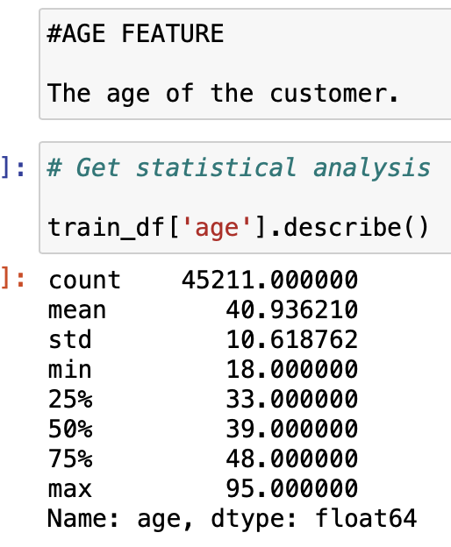

**Visualization Approach :**

* In our descriptive analysis, we employed various visualization techniques to complement our statistical summaries:

*Numerical Features:* For these, histograms with Kernel Density Estimates (KDE) were utilized. This approach allowed us to observe the distribution and identify skewness in the data. Box plots were also used to highlight outliers and the overall data spread.

*Categorical Features:* Bar charts were the primary tool for these features, providing a clear view of category frequencies and distributions. These visualizations were key in revealing underlying patterns and aiding in our understanding of each feature's characteristics. You can see some examples below :

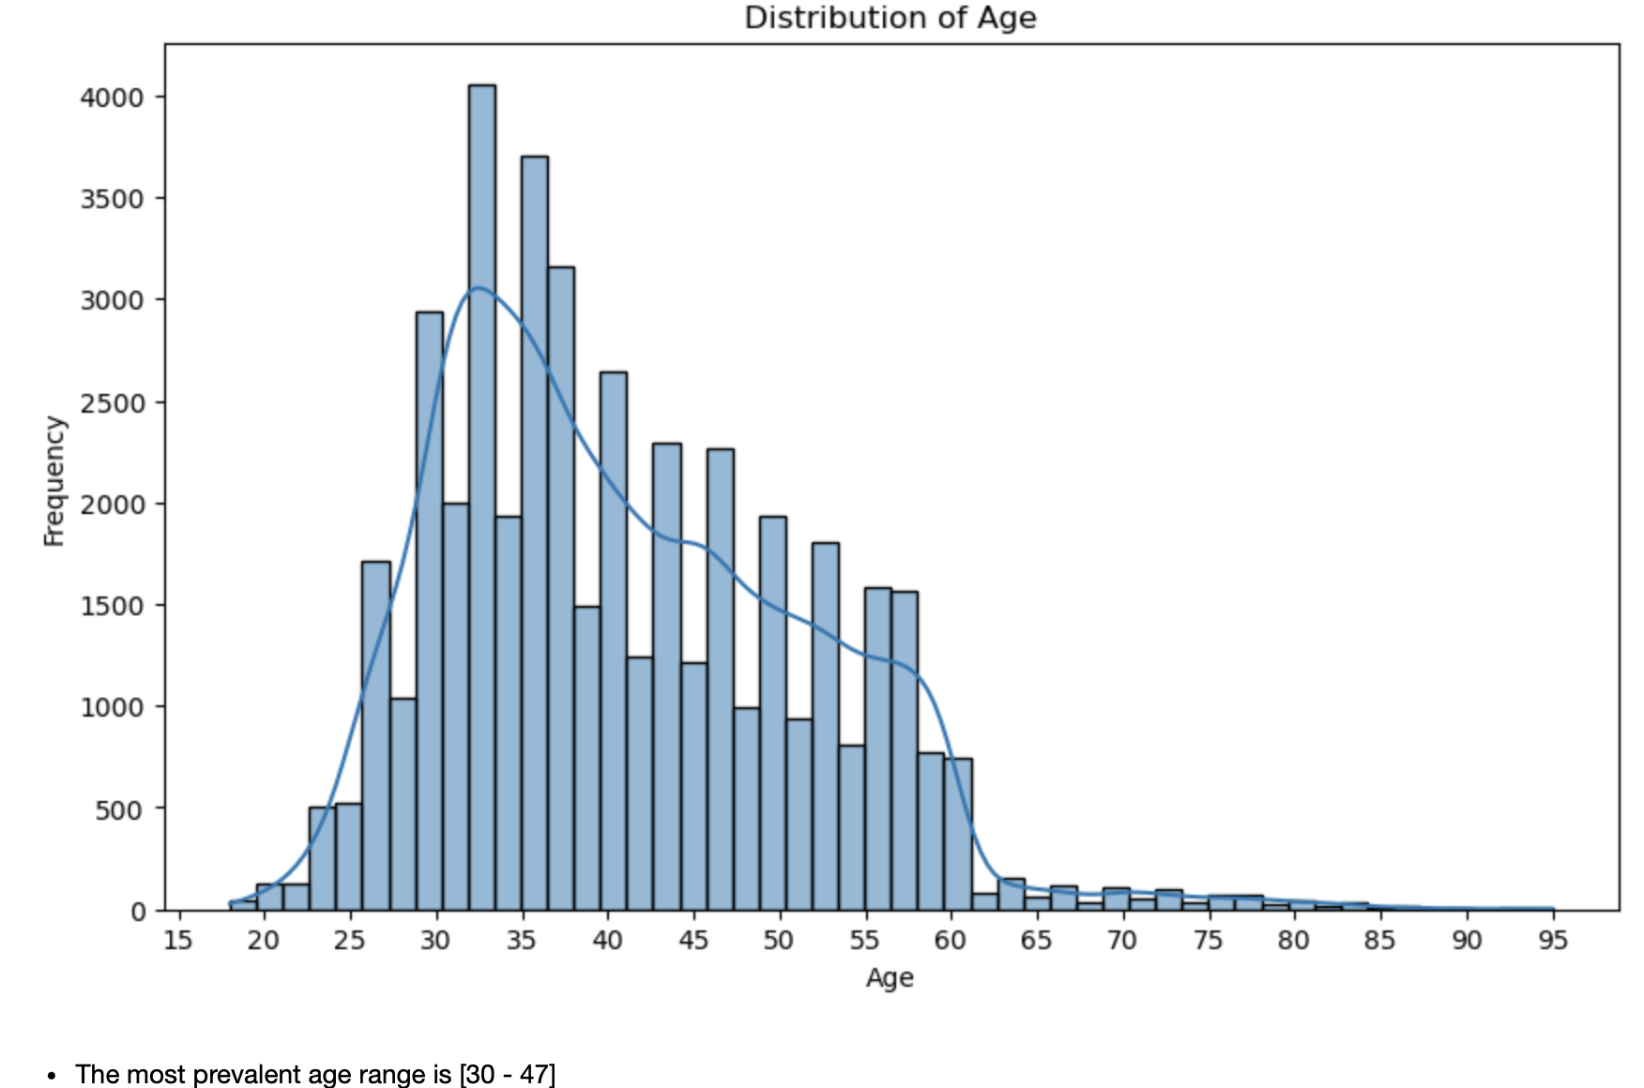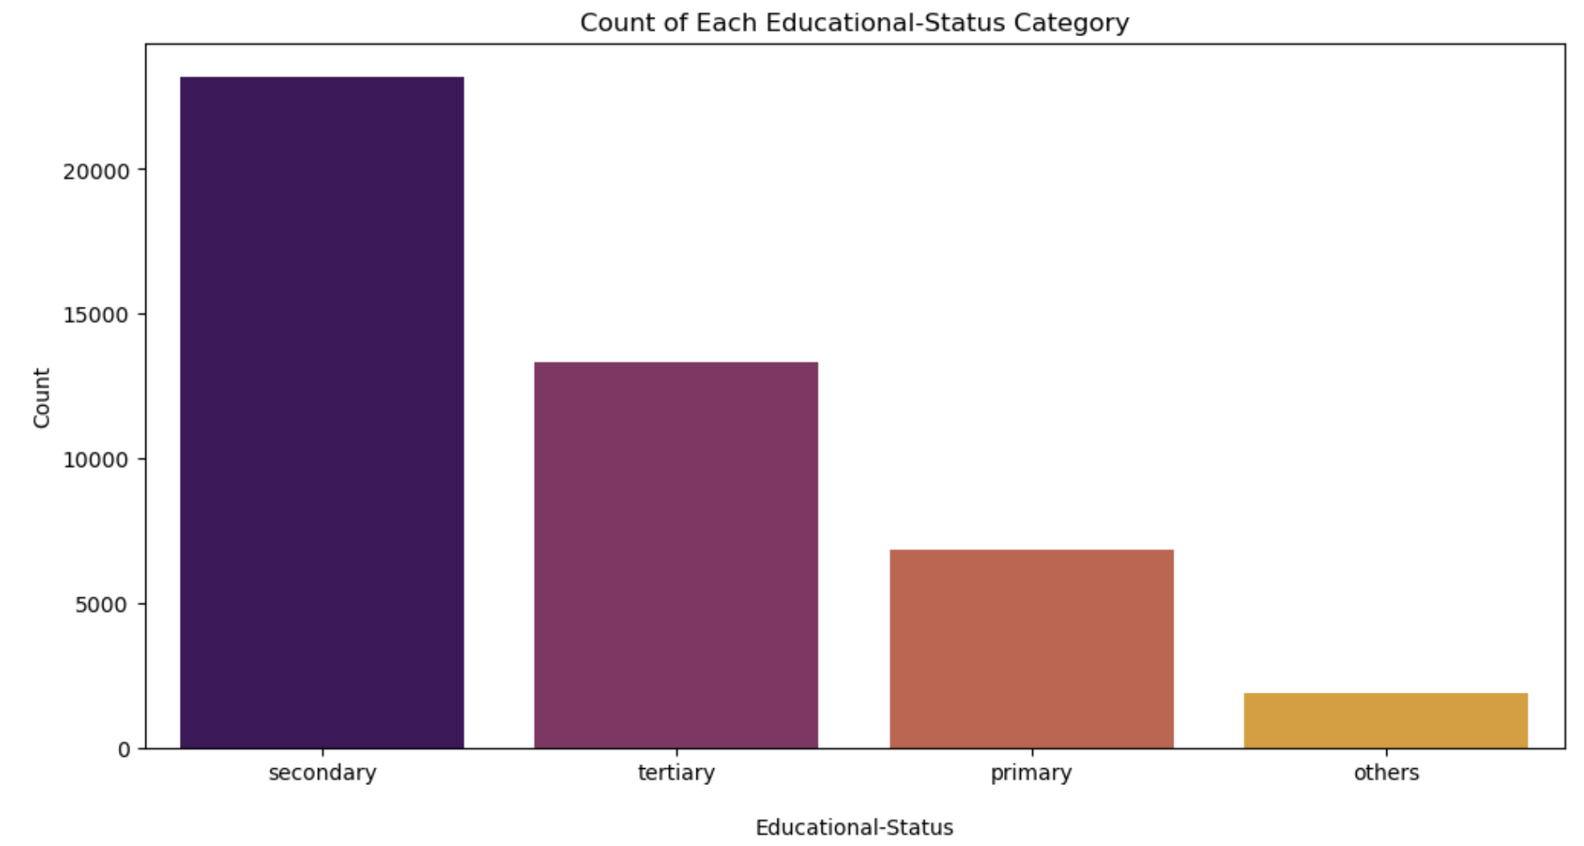

**Feature-Specific Analysis:**

* Each feature was examined individually to understand its unique characteristics. This level of detail helped us identify features with significant variance, unusual distributions, or imbalances that could influence the modeling process.
* We paid special attention to ensure that the visualizations and statistical analyses were aligned with the nature of each feature, whether numerical or categorical.

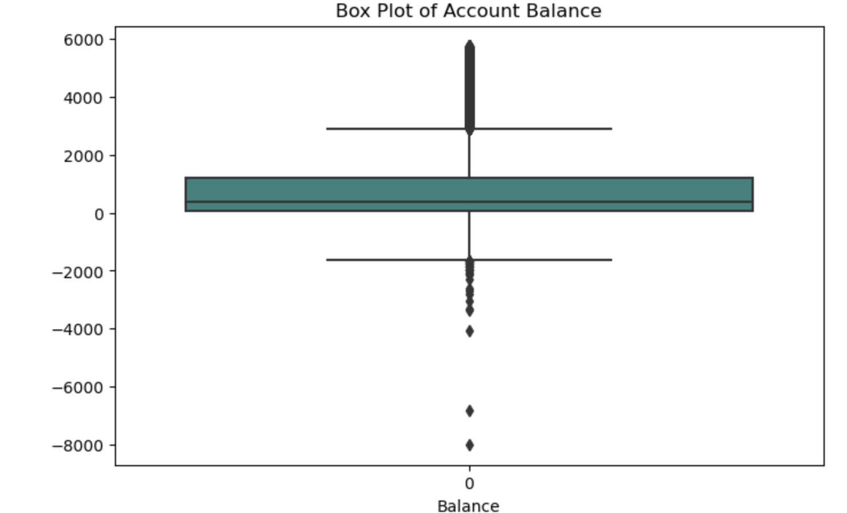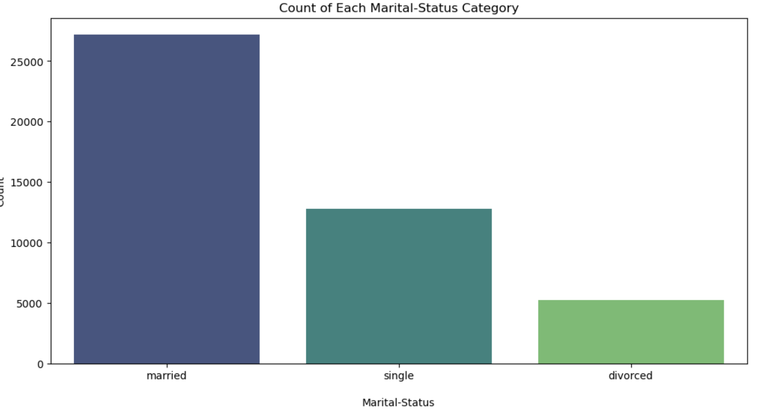

# DATA PREPROCESSING

*In this section, you have to perform at least one preprocessing operation per category (i.e., data cleansing, data transformation, data integration, data reduction) and report the results along with an explanation of why you selected that particular technique.*

In the data preprocessing stage, our focus was on enhancing the dataset's quality for more accurate predictive modeling. Here are some key steps:

**1.1 Feature Transformation**

- For features containing 'unknown' values, we transformed these entries into 'other'. This approach avoids data loss and ensures a more comprehensive representation of the dataset, enhancing the integrity of our analysis. For example:

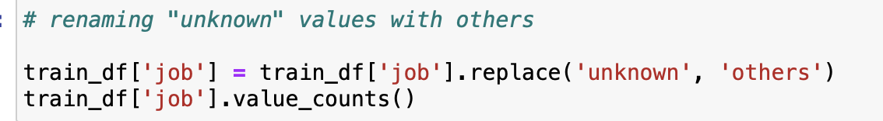

**1.2 Outlier Detection and Treatment**

We focused on addressing outliers in the **'balance'** feature, essential for the accuracy of our predictive model.

Identifying Outliers: We used statistical methods to identify upper outliers above the 95th percentile and lower outliers below the 5th percentile in the 'balance' data.

Removing Outliers: Outliers exceeding these thresholds were removed from the dataset, aiming to normalize the distribution of account balances.

Example Codeblock below:

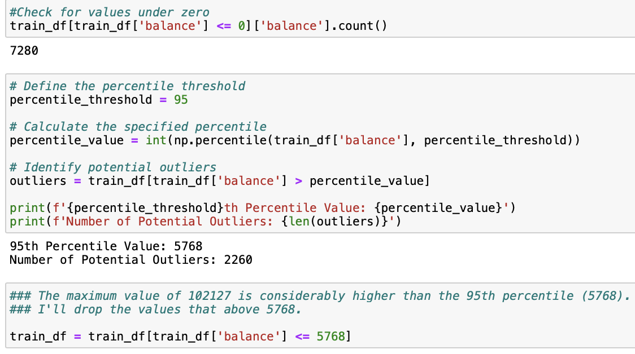

Results:

This approach was chosen to mitigate the skewing effect of extreme values on our model.

Post-removal, visualizations like KDE plots and box plots confirmed a more regularized distribution, improving the dataset's reliability for predictive analysis.

Handling outliers in the 'balance' feature was a crucial step in refining our dataset, setting a solid foundation for accurate modeling.

**1.3 Feature Reduction**

In our dataset, we identified certain features that, due to their characteristics, offered limited value for our predictive analysis. The decision to remove these features was driven by their distribution and the nature of their data, which could potentially skew our model's performance.

**a)'Default' Feature**

- Observation: A detailed examination of the 'default' feature revealed a highly skewed distribution, where the vast majority of values were 'no'.

- Action: Considering its overwhelming imbalance and the likelihood of minimal impact on the predictive outcome, we decided to drop this feature.

**b) Previous' Feature:**

- Observation: The 'previous' feature predominantly consisted of 0 values. This lack of variance indicated that the feature wouldn't contribute significantly to differentiating outcomes in our predictive model.

- Action: Based on this observation, the 'previous' feature was removed to simplify the model and focus on more informative attributes.

**c). Poutcome' Feature:**

-Observation: We noted that a substantial portion of the 'poutcome' (outcome of the previous marketing campaign) data was categorized as 'unknown', limiting its usefulness and reliability for analysis.

- Action : To avoid the potential bias and inaccuracies this could introduce, we opted to exclude 'poutcome' from our dataset.

Here is an example codeblock:

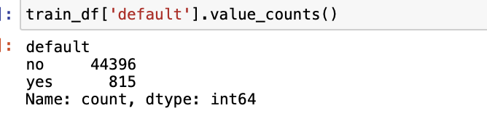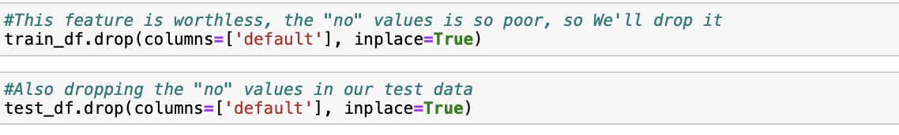

'Default', 'previous', and 'poutcome' feature reduction was an important part of our preprocessing stage. It demonstrates our dedication to adjusting the dataset for the best possible predictive performance, guaranteeing the accuracy and applicability of our analysis.

**1.4 Encoding Categorical Features**

One crucial step in preprocessing was the transformation of categorical variables into a format that can be easily used by machine learning algorithms.

a) Label Encoding:

- Process: We utilized Label Encoding, converting each categorical value into a unique integer. This step was implemented using the `LabelEncoder` from the scikit-learn library.

- Rationale: Many machine learning models, especially those based on mathematical functions, require numerical input. Label Encoding transforms categorical data into a machine-readable form without expanding the feature space.

Here are example images for before and after the *encoding* process:

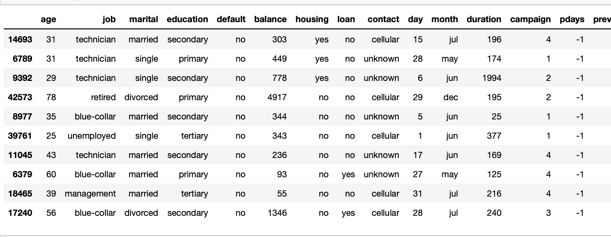

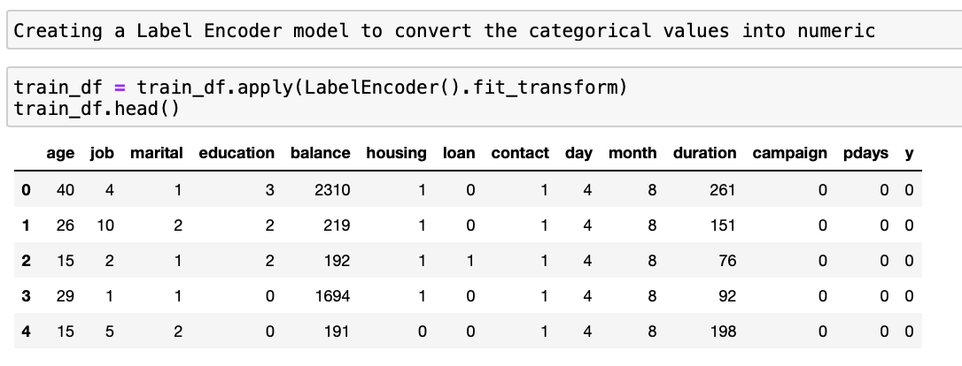

**1.5 Correlation Analysis**

Understanding the relationships between different features is vital for building effective models.

a) Correlation Matrix Computation

- Procedure: We calculated a correlation matrix for the dataset. This matrix quantifies the degree to which different variables are linearly related.

- Purpose: The correlation matrix helps in identifying features that are highly correlated with each other. Features with high multicollinearity can negatively impact some models, and identifying them early is key for potential feature selection or removal.

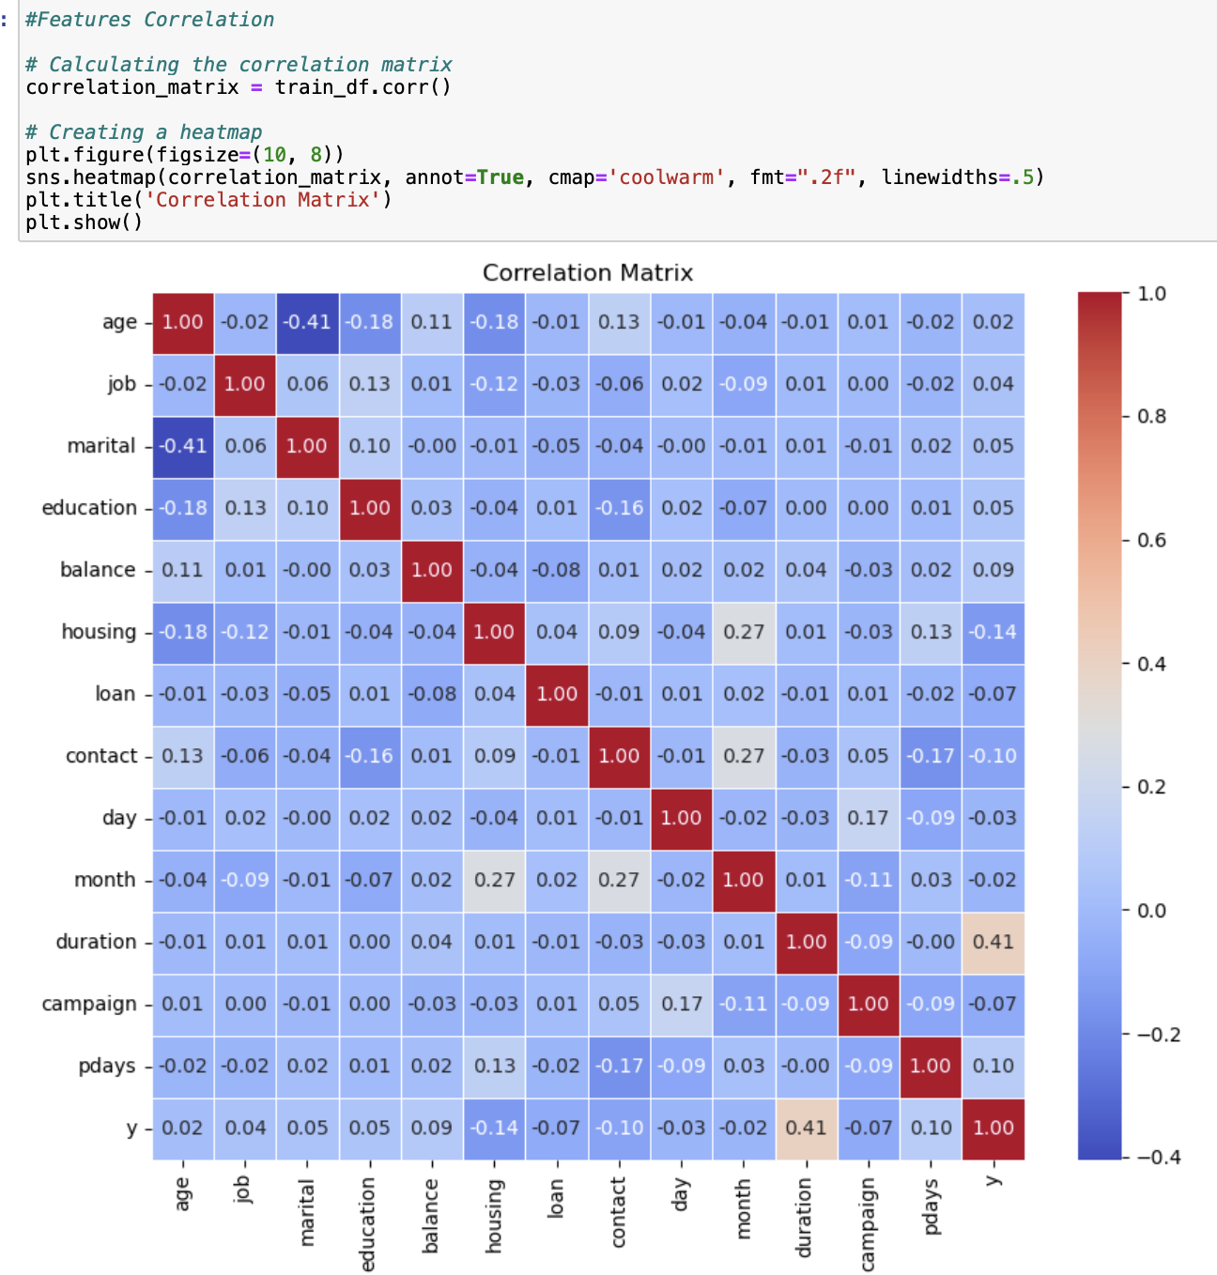

**1.6 Train-Test Split**

**a)Implementation:**

- We divided our dataset into `X_train`, `y_train` for training, and `X_test`, `y_test` for testing purposes. The `X` variables contain the input features, while `y` refers to the target variable.

**b)Purpose:**

- This division is crucial for evaluating the performance of our machine learning models. It allows models to learn and adapt to patterns in the training data (`X_train`, `y_train`) and subsequently be evaluated on unseen data (`X_test`, `y_test`).

The Train-Test Split is an essential step in machine learning preprocessing, ensuring that our models are tested on unbiased, unseen data, thereby providing a realistic assessment of their predictive performance.

# MACHINE LEARNING IN ACTION

## Selected algorithms

*Please provide a concise yet informative introduction to the ML algorithms you selected. You should be using at least two algorithms for unsupervised learning projects, and three for supervised learning algorithms.*

In our project, we employed three distinct supervised learning algorithms: Logistic Regression, K-Nearest Neighbors (KNN), and Decision Trees. Each of these methods offers unique advantages and approaches to predictive modeling, making them suitable for our objective of predicting outcomes in a bank's direct marketing campaign.

**4.1.2 Logistic Regression**

a). Overview: Logistic Regression is a fundamental classification algorithm in machine learning. It is particularly effective for binary classification tasks.

b)Working Principle: This method models the probability of a binary outcome using a logistic function. It estimates the relationship between the dependent binary variable and one or more independent variables.

c) Application in Our Project: We utilized Logistic Regression for its efficiency and simplicity in predicting binary outcomes, such as whether a customer will subscribe to a term deposit.

d) Implementation: In our project, we applied Logistic Regression with an L2 penalty and a regularization strength (C) of 1.0. We set the maximum number of iterations to 1000 to ensure convergence.

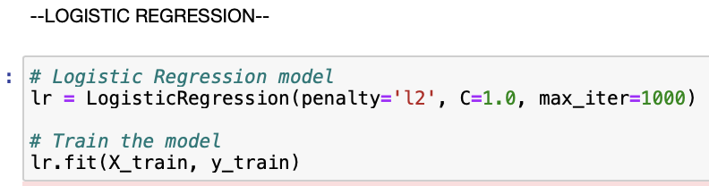

**4.1.3 K-Nearest Neighbors (KNN)**

a) Overview: KNN is a non-parametric, instance-based learning algorithm widely used for classification and regression.

b) Working Principle: It classifies a data point based on how its neighbors are classified. The algorithm looks at the K-nearest neighbors (where K is a specified number) and assigns the class based on the majority class of these neighbors.

c) Rationale for Use: We chose KNN for its intuitive nature and ability to make predictions based on the similarity of data points, offering a more nuanced understanding of customer behavior.

d) We utilized the K-Neighbors Classifier with n_neighbors set to 5, allowing the algorithm to consider the five nearest data points for classifying a new instance.

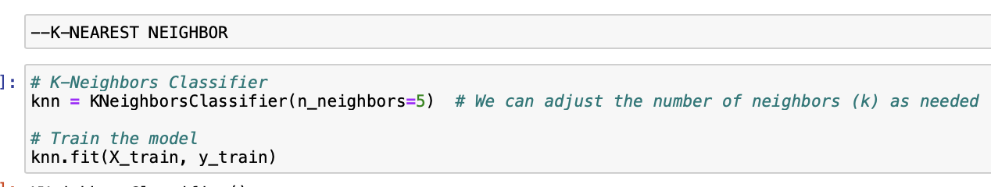

**4.1.4 Decision Trees**

a). Introduction: Decision Trees are versatile algorithms used for both classification and regression tasks.

b) Functionality: They model decisions and their possible consequences as a tree-like structure, where each internal node represents a test on an attribute, each branch represents the outcome of the test, and each leaf node represents a class label or decision.

c) Advantages in Our Context: In our project, Decision Trees were valuable due to their interpretability. They provide clear visualizations of the decision-making process, helping us understand the factors influencing customer decisions.

d) Setup: The Decision Tree model was implemented with a specified random_state for reproducibility.

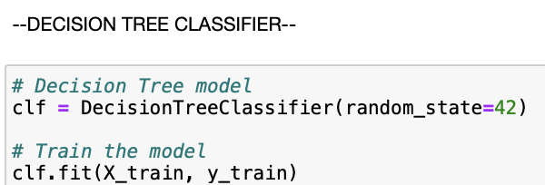

These three algorithms work together to provide the framework for our predictive analysis. Logistic Regression delivers simplicity and effectiveness for binary outcomes, KNN contributes its expertise in recognizing patterns based on data point similarities, and Decision Trees provide depth with its accessible and visual decision-making structure.

By combining these methods, we may approach our prediction problem from multiple perspectives, which improves the flexibility and accuracy of our findings.

## Performance measurement

*Please explain how you measure the performance of the selected algorithms.*

In our project, we utilized a combination of metrics to evaluate the performance of each machine learning algorithm: Logistic Regression, K-Nearest Neighbors (KNN), and Decision Trees. These metrics provided a comprehensive view of each model's effectiveness in predicting the outcomes of the bank's marketing campaigns.

**4.2.1 Accuracy Score**

a). Method: We calculated the accuracy score for both the training and testing datasets.

b) Application: This was done using the `.score()` method on each model, which provided insights into how well the model performs in terms of correctly predicting outcomes.

c) Significance: The accuracy score, representing the ratio of correctly predicted observations to the total observations, was crucial in assessing the overall effectiveness of each algorithm.

**4.2.2 Confusion Matrix**

a) Construction: For each model, we created a confusion matrix using the `confusion_matrix` function from scikit-learn.

b) Application: This was achieved by comparing the actual test outcomes (`y_test`) against the predictions made by the model (`y_pred`).

c) Utility: The confusion matrix helped us understand not just the errors of the models, but also the type of errors – whether they were false positives or false negatives.

**4.2.3 Classification Report**

1. Generation: We used the `classification_report` function from scikit-learn to generate a detailed classification report for each model.

b) Content: These reports provided key metrics such as precision, recall, and F1-score for each class.

- *Precision:* Precision indicates the proportion of positive identifications that were actually correct. It is calculated as the number of true positives divided by the sum of true positives and false positives.

- *Recall (Sensitivity):* Recall measures the proportion of actual positives that were identified correctly. It is calculated as the number of true positives divided by the sum of true positives and false negatives.

- *F1-Score:* The F1-Score is the harmonic mean of precision and recall, providing a balance between these two metrics. It is particularly useful when the class distribution is imbalanced. The F1-Score reaches its best value at 1 (perfect precision and recall) and worst at 0.

- *Support:* This represents the number of actual occurrences of each class in the specified dataset. It is useful for assessing the evaluation metrics in the context of class imbalance.

These metrics collectively offer a comprehensive view of a model's performance, beyond mere accuracy, by considering both the precision of predictions and the model's ability to identify all relevant cases.

c) Relevance: The classification report was particularly useful for evaluating the performance of our models in a more nuanced manner. Precision and recall are critical in scenarios where the cost of false positives or false negatives varies, and the F1-score provides a balance between precision and recall.

By applying these performance measurement techniques uniformly across all three algorithms, we were able to conduct a fair and comprehensive evaluation. The combination of accuracy scores, confusion matrices, and classification reports allowed us to not only assess the overall prediction accuracy of each model but also to delve deeper into the specifics of their predictive capabilities. This multi-metric approach was instrumental in identifying the strengths and weaknesses of each algorithm, guiding our decision-making process for model selection and refinement.

## Experiments

*This section will detail how you set up the experiments using different subsets, model-related parameters, performance improvement techniques, etc.*

**4.3.1 Experiments we set up for Logistic Regression:**

**Original Setup and Variations**

1. **Original Configuration:**

- We began with a standard Logistic Regression model, employing an L2 penalty, a regularization strength (`C`) of 1.0, and the 'liblinear' solver. The model was trained on our training dataset and achieved an accuracy of approximately 88.74% on the test set.

- This initial setup served as our baseline for comparison with subsequent experiments.

**b) Parameter Tuning Experiments:**

- To explore the impact of different configurations on model performance, we experimented with varying the `C` value and the penalty type.

*- Varying `C` Values:* The `C` parameter, which controls the strength of regularization, was varied among 0.01 (strong regularization), 1.0 (moderate regularization), and 10 (weak regularization).

*- Penalty Type:* We tested both L1 and L2 penalties. The L1 penalty can lead to sparser solutions, potentially beneficial for feature selection, while the L2 penalty is known for its stability, especially with correlated features.

**c)Analysis**

*- Baseline Accuracy:*

The original Logistic Regression model, set with an L2 penalty and a `C` value of 1.0, achieved an accuracy of approximately 88.74%. This served as our benchmark for comparison.

*- Variations in Regularization and Penalty:*

*-*We tested different configurations by varying `C` values (0.01, 1.0, 10) and penalties (L1, L2).

- Accuracy scores ranged from about 88.54% to 88.78%, with the highest being 88.78% under specific configurations.

*- Finding Out The Coefficients Of The Features:*  
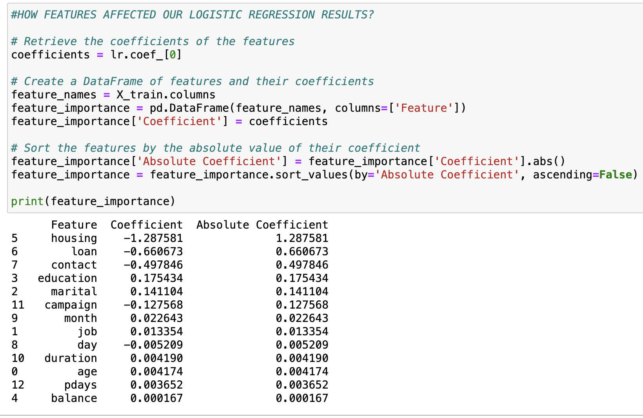

- The coefficients indicate the direction of the relationship with the target variable: positive coefficients imply a positive correlation, while negative coefficients suggest a negative correlation. The "Absolute Coefficient" highlights feature importance, with higher absolute values indicating a stronger impact on predictions. For instance, a negative coefficient of approximately -1.29 for "housing" implies that clients with housing are less likely to meet the target condition than those without.

**Comparative Insights**

*- Influence of `C` Value:*

- The change in the `C` value, which adjusts the strength of regularization, had a noticeable but not drastic effect on the model's accuracy.

- Lower `C` (stronger regularization) did not significantly improve the model, suggesting that our dataset might not be highly prone to overfitting.

*- Effect of Penalty Type:*

- The L1 penalty slightly outperformed the L2 penalty in some configurations, particularly at `C` values of 1.0 and 10.

- This suggests that the L1 penalty, which can simplify the model by reducing certain feature coefficients to zero, might be more suitable for this dataset.

*- Stability Across Configurations:*

- The relatively small variation in accuracy across different setups indicates that the Logistic Regression model is quite stable for this particular dataset.

- It suggests that the dataset characteristics and feature relevance are well-captured by the Logistic Regression algorithm, regardless of minor tuning.

**Concluding Thoughts**

The detailed analysis of the Logistic Regression experiments reveals insights into the impact of regularization strength and penalty type on model performance. The highest accuracy of 88.78% indicates a well-performing model, but the marginal differences between configurations highlight that the choice of `C` value and penalty type, while important, should be considered alongside other aspects of model development and feature engineering. This experiment underscores the nuanced balance in parameter tuning for achieving optimal model performance.

**4.3.2 Experiments We Set Up For KNN:**

In our project, we implemented several algorithms, with K-Nearest Neighbors (KNN) being a key focus due to its efficacy and simplicity in classification tasks. KNN is a non-parametric, instance-based learning algorithm that is particularly useful for its intuitive approach to predictions based on proximity and similarity.

**a) Basic Implementation:**

- Initially, we employed the K-Neighbors Classifier with the default setting of 5 neighbors. This configuration is often a starting point as it balances the bias-variance tradeoff effectively.

**b) Experimenting with Number of Neighbors:**

- Understanding the impact of the number of neighbors on KNN's performance, we conducted experiments by varying this parameter.

- We tested with 7 neighbors, observing how the increase in neighbor count affects the prediction accuracy.

**c) Results and Insights from K-Nearest Neighbors (KNN) Experiments**

*-KNN with 5 Neighbors:*

- Accuracy Achieved: The model configured with 5 neighbors yielded an accuracy of about 91.04%.

- Insight: This high level of accuracy suggests that a relatively small neighborhood was sufficient to capture the patterns in the data effectively. The choice of 5 neighbors likely provided a good balance, allowing the model to generalize well without being too sensitive to noise in the data.

*- KNN with 7 Neighbors:*

- Accuracy Achieved: When the number of neighbors was increased to 7, the model's accuracy slightly decreased to approximately 90.44%.

- Insight: The reduction in accuracy, although modest, points towards the model starting to incorporate more distant neighbors into the decision process. This could mean that for our specific dataset, adding more neighbors beyond a certain point doesn’t contribute to, or may even detract from, the model’s ability to make accurate predictions.

**Comparative Analysis**

- Understanding Neighbor Effect: The contrast in performance between 5 and 7 neighbors, albeit slight, is significant. It indicates the sensitive nature of KNN to the neighbor parameter. With more neighbors, the model's decision boundary becomes smoother, which can be beneficial for generalization but may also lead to underfitting in certain cases.

- Dataset Specificity: The results reflect how KNN's performance is closely tied to the dataset's characteristics. In datasets where the decision boundary is expected to be more nuanced, a smaller number of neighbors might capture the complexities better. Conversely, smoother boundaries might benefit from a larger neighbor count.

- Bias-Variance Tradeoff: These experiments highlight the classic bias-variance tradeoff in KNN. Fewer neighbors can lead to a model with high variance but low bias, while more neighbors typically result in a model with lower variance but potentially higher bias.

**Concluding Thoughts**

The nuanced differences observed with the variation in the number of neighbors in KNN emphasize the importance of this parameter in model tuning. Our experimentation reflects a careful consideration of how the neighbor count affects the model's ability to make accurate predictions, providing valuable insights into the optimal configuration for our specific dataset.

**4.3.3 Experiments We Set Up For Decision Tree**

Decision Trees are an extremely understandable and flexible method that can be used for both regression and classification applications, and we used them in our supervised learning project.

1. **Standard Decision Tree Model:**

- Initially, we employed a basic Decision Tree model with a set random state to ensure reproducibility.

- While the model achieved perfect accuracy on the training set, it scored around 89.60% accuracy on the test set, indicating its effective learning capability but also suggesting some overfitting.

**b ) Decision Tree with Limited Features and Depth:**

- In a subsequent experiment, we refined our approach by limiting the model to use only two features: 'age' and 'balance'. Simultaneously, we restricted the tree's depth to 3.

- This dual modification aimed to reduce the model's complexity, potentially mitigating overfitting, and to focus on the predictive strength of these specific features.

**c) Results and Insights**

- Performance of Full-Feature Model: The high accuracy on the training set and a strong but lesser accuracy on the test set indicated the model's effectiveness in learning but also raised concerns regarding its generalizability.

- Impact of Feature and Depth Restriction: The modified Decision Tree, utilizing only 'age' and 'balance' with limited depth, achieved an accuracy of about 82.70%.

This outcome highlights the role of other features in the dataset and demonstrates how controlling the depth can influence the model’s balance between learning complex patterns and generalizing well to new data.

**Conclusion**

Through our Decision Tree experiments, we gained insights into the effects of feature selection and model complexity on performance. These findings emphasize the delicate balance in machine learning between capturing sufficient detail from the training data and maintaining the model’s ability to generalize. The adaptability of Decision Trees to such modifications underscores their value in our array of machine learning techniques.

## Results

*Simply report the results in an engaging manner using tables, figures,etc.*

**Results of Machine Learning Algorithms We Applied:**

* Logistic Regression Initial Results:

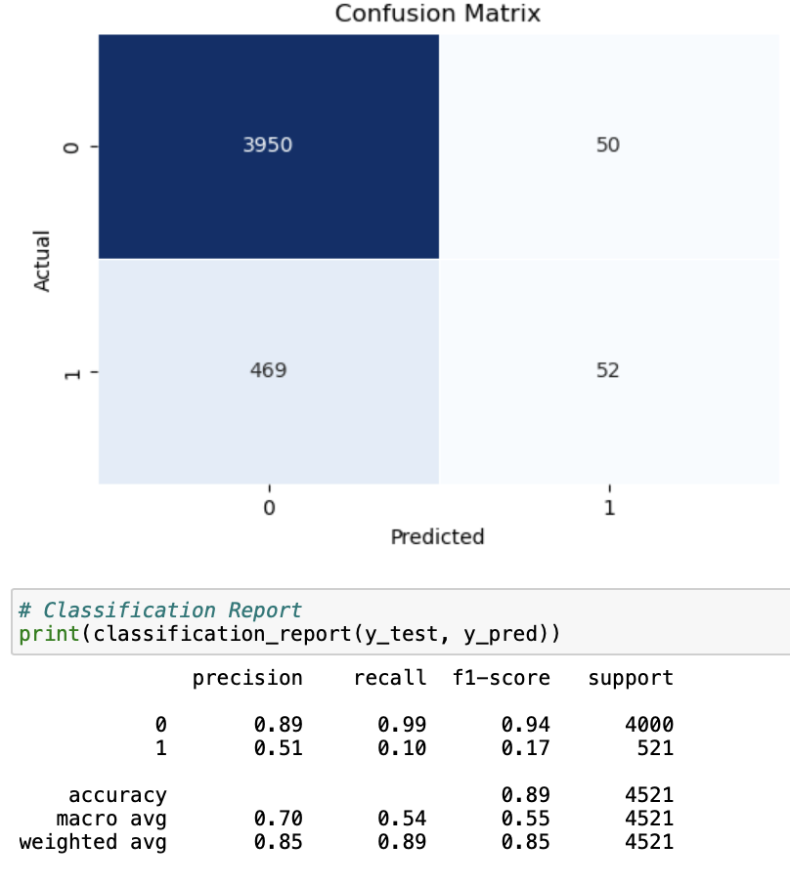

* K-Nearest Neighbor KNN Initial Results:

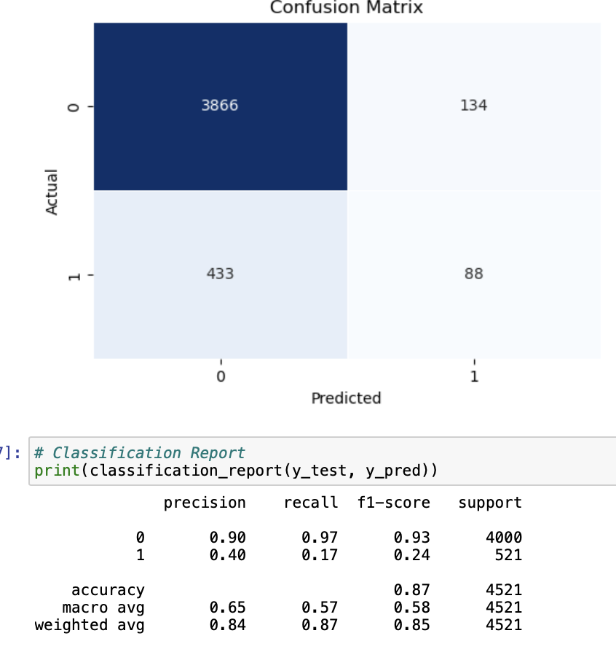

* Decision Tree Initial Results:

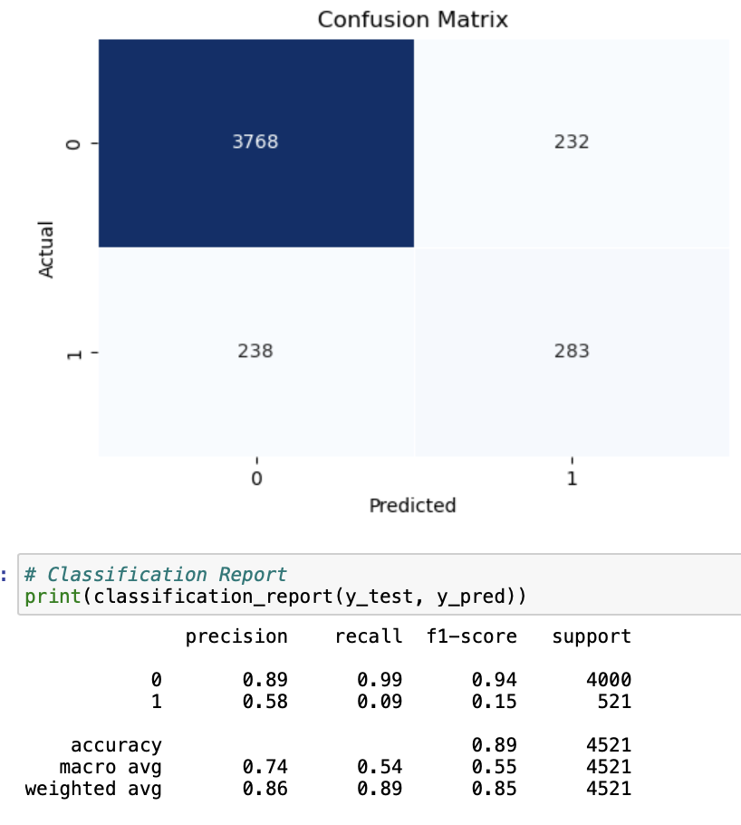

# INSIGHTS

*This may be the most important part of this project. I am expecting enlightening insights here rather than stating the obvious. Communicate the results in a way that interests, even surprises, the readers.*

When creating new marketing initiatives, banks can benefit greatly from the application of machine learning (ML) techniques. ML can forecast customer reactions to upcoming efforts by examining past data and customer profiles, enabling more focused and effective marketing campaigns. Increased client happiness, lower marketing expenses, and higher conversion rates are the results of this focused strategy. Furthermore, machine learning (ML) assists in recognizing new trends and shifting consumer preferences, allowing banks to proactively modify their products. In the fast-paced financial market of today, where data-driven and customized solutions are essential to preserving a competitive edge, this method is priceless.

The power and importance of characteristics like marital status can be dramatically changed by economic situations, as we must acknowledge while analyzing the "Direct Marketing Campaigns for Bank Term Deposits" dataset. For example, in a stable economic environment, being single may be connected with lower family expenses and a stronger propensity to invest. But in an economic downturn, stress and uncertainties on finances can change this assumption. Regardless of their marital status, people may start making more conservative financial decisions. This realization emphasizes how crucial it is to place our forecasting models in the context of the contemporary economy. The elements affecting consumer behavior will change along with the state of the economy.

In order to effectively modify their plans and stay relevant and responsive to the constantly shifting financial needs and realities of their clientele, banks must have a sophisticated awareness of these dynamics. This method emphasizes the significance of constant attention to detail and flexibility in predictive modeling within the banking industry, particularly in view of the uncertainties surrounding the world economy.

The way banks and customers engage changes dramatically during a recession. Banks have historically concentrated on luring clients in for investments. But during a crisis, attention shifts to examining the creditworthiness of loan applicants. The bank's customer engagement and data analysis techniques are significantly impacted by this shift in dynamics. Banks must improve their predictive models, giving financial risk assessment and possible borrower stability first priority. This calls for shifting their methods from encouraging investments to managing risks, in addition to responding to the increasingly cautious and risk-averse habits of their customer base. Bank data analysts are therefore faced with the challenge of creating increasingly complex and flexible analytical techniques. These strategies need to effectively navigate the particulars of a recession, when financial stability and client dependability become critical.

Even with advanced ML techniques at their disposal, the role of data analysts in banks extends beyond mere technical proficiency. Their social skills, sociological background, and perception are essential for modifying strategies in response to the changing circumstances of a financial crisis. Data must be interpreted by analysts taking into account changes in society and human behavior, then incorporating these observations into their models. This comprehensive method guarantees that tactics are not just data-driven but also considerate of the needs of customers, resulting in more efficient and humane banking procedures—especially important in hard economic times.

The logistic regression model's output reveals a compelling narrative about the factors influencing customer decisions regarding term deposits. The 'housing' feature, with its high negative coefficient, suggests that customers with housing loans are less likely to subscribe to term deposits, possibly due to their existing financial burdens. Similarly, 'loan' as a negative influencer indicates a reluctance among those with personal loans to make additional financial commitments. The negative coefficient for 'contact' could reflect the impact of the communication method on customer decisions. On the other hand, 'education' and 'marital' status, although having smaller positive coefficients, hint at a demographic segment more inclined towards term deposits. Interestingly, the relatively low coefficients for 'age', 'balance', and 'duration' suggest these factors, while relevant, are less decisive in this context. This detailed analysis underscores the importance of understanding customer profiles and their financial backgrounds in tailoring banking services and marketing strategies

# REFERENCES

Singal, A. (n.d.). Andyrasika/banking-marketing · datasets at hugging face. Andyrasika/banking-marketing · Datasets at Hugging Face. https://huggingface.co/datasets/Andyrasika/banking-marketing

*Bank Term Deposit Predictions*. (2023, November 30). Kaggle. <https://www.kaggle.com/datasets/thedevastator/bank-term-deposit-predictions>

A. (2023, December 15). *Bank Term Deposit Prediction*. Kaggle. <https://www.kaggle.com/code/abdallahwagih/bank-term-deposit-prediction>

T. (2023, December 10). *Complete Project Data Analysis and ML Modeling*. Kaggle. https://www.kaggle.com/code/tjrodr1/complete-project-data-analysis-and-ml-modeling

N. N. (2021, January 13). *Decision Tree Classification Clearly Explained!* YouTube. https://www.youtube.com/watch?v=ZVR2Way4nwQ

N. (2022, May 29). *Visualizing Decision Trees in Python*. YouTube. <https://www.youtube.com/watch?v=R15Rm_aW1jM>

S. O. (2020, April 17). *Stanford CS229: Machine Learning Course, Lecture 1 - Andrew Ng (Autumn 2018)*. YouTube. <https://www.youtube.com/watch?v=jGwO_UgTS7I>

S. W. J. S. (2018, March 5). *StatQuest: Logistic Regression*. YouTube. <https://www.youtube.com/watch?v=yIYKR4sgzI8>

R. (2022, May 18). *Step by Step Tutorial on Logistic Regression in Python | sklearn |Jupyter Notebook*. YouTube. <https://www.youtube.com/watch?v=bSXIbCZNBw0>

P. (2020, March 2). *Machine Learning Tutorial 13 - K-Nearest Neighbours (KNN algorithm) implementation in Scikit-Learn*. YouTube. <https://www.youtube.com/watch?v=OO7Y5wQWnQs>

M. T. (2021, June 11). *How to Implement Decision Trees in Python (Train, Test, Evaluate, Explain)*. YouTube. <https://www.youtube.com/watch?v=wxS5P7yDHRA>

K. N. D. S. M. (2020, March 25). *sklearn Logistic Regression hyperparameter optimization*. YouTube. <https://www.youtube.com/watch?v=pooXM9mM7FU>

C. (2019, October 29). *K Nearest Neighbors Part 9 - Hyper-parameters*. YouTube. <https://www.youtube.com/watch?v=LRu9kAuaQKM>

Gupta, A. (2023, December 21). *Feature Selection Techniques in Machine Learning (Updated 2024)*. Analytics Vidhya. <https://www.analyticsvidhya.com/blog/2020/10/feature-selection-techniques-in-machine-learning/>

*What Is Data Reduction?* (2022, February 25). https://www.purestorage.com/knowledge/what-is-data-reduction.html#:~:text=Data%20reduction%20is%20a%20capacity,as%20possible%20to%20maximize%20capacity

Gawali, S. (2023, December 28). *Skewness and Kurtosis: Quick Guide (Updated 2024)*. Analytics Vidhya. https://www.analyticsvidhya.com/blog/2021/05/shape-of-data-skewness-and-kurtosis/#:~:text=The%20skewness%20is%20a%20measure,pushed%20towards%20the%20left%20side

*What is Machine Learning? | IBM*. (n.d.). https://www.ibm.com/topics/machine-learning

*Topics | IBM*. (n.d.). https://www.ibm.com/topics#:~:text=Resources-,What%20is%20linear%20regression%3F,is%20called%20the%20independent%20variable